**AWS Task-4**

**Task Description:**

Launch an EC2 instance (Linux and Windows) along with a web server. Then, create an EBS volume of 5 GB, attach it to an EC2 machine (Linux and Windows), and take a snapshot. Finally, create an EBS volume using the taken snapshot.

**Created EC2 linux instance:**

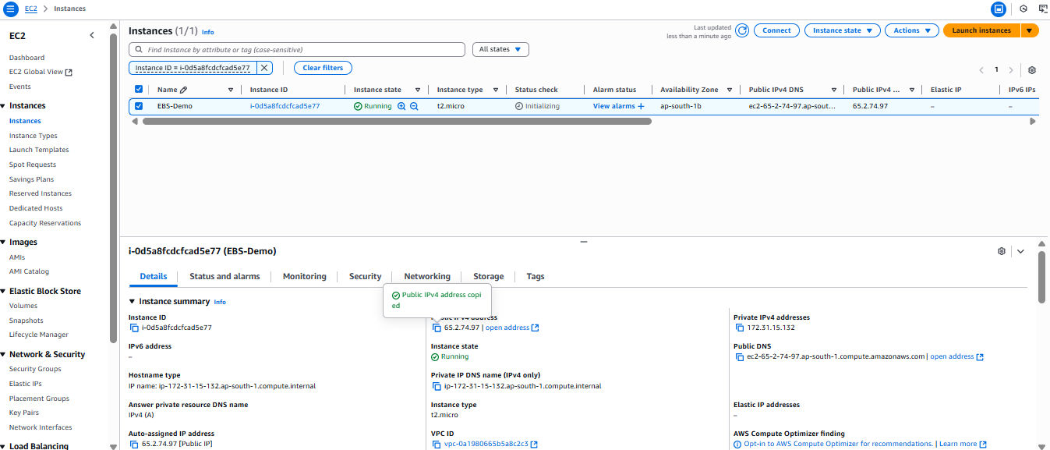

**Created 5 GB Volume and attaching to the EC2 Linux Machine:**

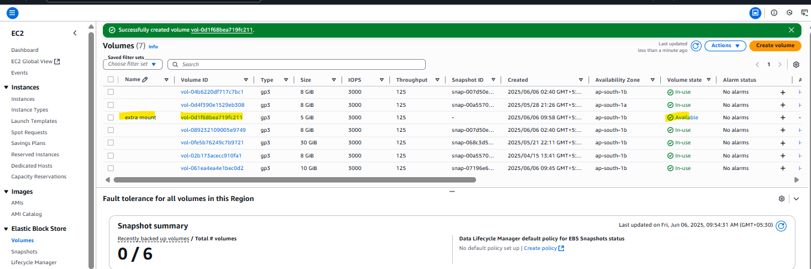

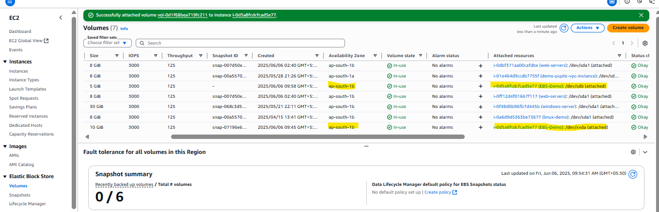

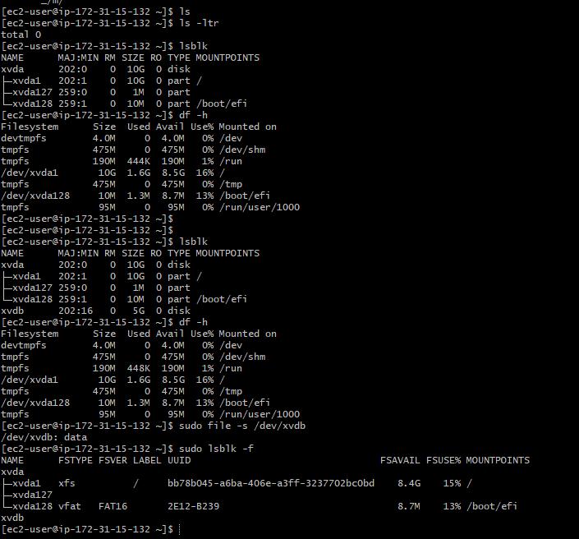

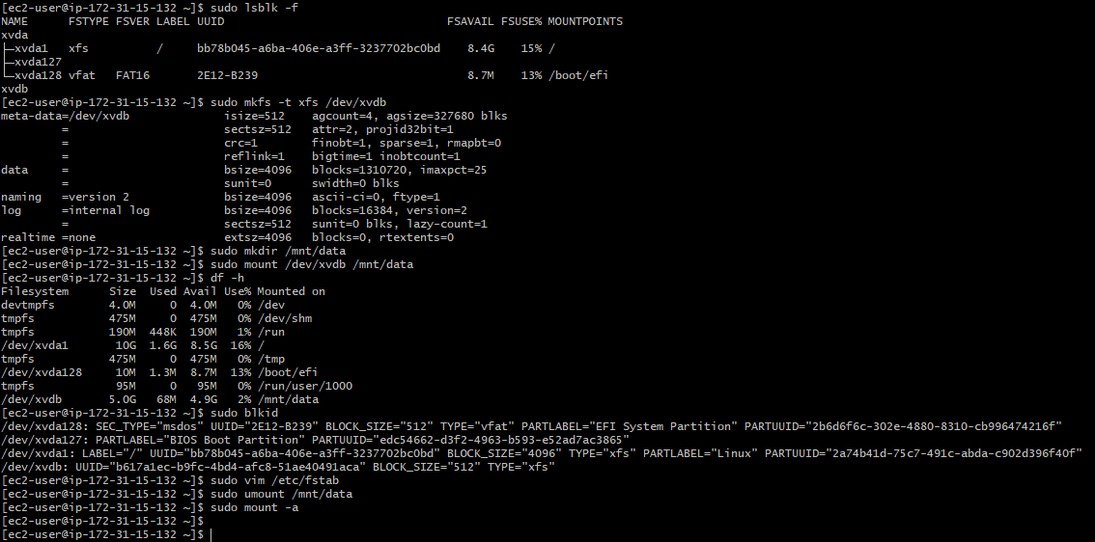

**Snapshot created for extra volume:**

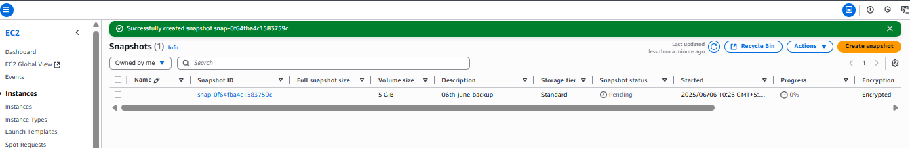

**Created a EBS Volume using taken snapshot:**

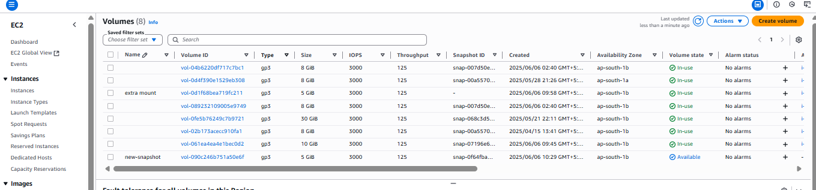

**Windows machine logged by using public IP through RDP:**

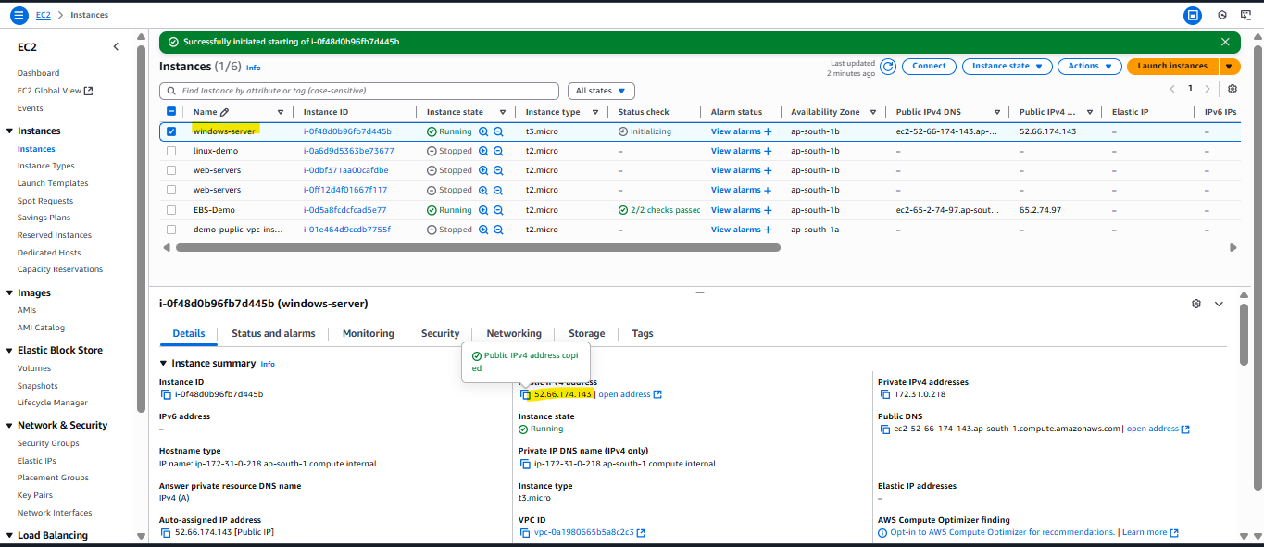

**Attached volume in windows server:**

